**SOFTWARE ENGINEERING**



**Session: 2022 – 2026**

**Submitted by:**

Raveeha Mohsin 2022-CS-149

Tayyaba Afzal 2022-CS-134

**Supervised by:**

Sir Amjad Farooq

Department of Computer Science

**University of Engineering and Technology**

**Lahore , Pakistan**

**Contents**

1 Presentation Layer 3

1.1 Role 3

1.2 Technologies 3

1.3 Functionalities 3

2 Business Logic Layer (Application Layer) 4

2.1 Role 4

2.2 Technologies 4

2.3 Functionalities 5

3 Data Access Layer (Database Layer) 7

3.1 Role 7

3.2 Technologies 7

3.3 Database Tables 7

3.4 ERD (Entity Relationship Diagram) 9

3.5 Data Access Logic: 10

4 Layered Communication Flow 11

5 Example Breakdown for Career Path Navigator Features 12

5.1 User Login (Authentication) 12

5.2 Admin Dashboard 12

5.2.1 View & Manage Users (Admin) 12

5.2.2 View Feedback (Admin) 13

5.3 Counselor Dashboard 13

5.3.1 Manage Availability (Counselor) 13

5.3.2 Schedule and Conduct Meetings (Counselor) 13

5.3.3 View Feedback (Counselor) 14

5.4 Student Dashboard 14

5.4.1 Profile Management (Student) 14

5.4.2 View all Recommendation & Courses 14

5.4.3 View and Apply for Jobs (Student) 14

5.4.4 Schedule Meetings with Counselors (Student) 15

5.4.5 Provide Feedback (Student) 15

6 Tools and Frameworks 16

**Layered Architecture Design for Career Path Navigator**

# Presentation Layer

## Role

This is the front-end layer responsible for interacting with users such as **students**, **counselors**, and **administrators**.

## Technologies

* **React.js** (for building dynamic user interfaces and components)
* **JavaScript** (for handling client-side logic and interactivity)
* **HTML/CSS** (for structuring the UI and applying styles)
* **Bootstrap** & **Tailwind CSS** (for responsive, utility-first design)
* **AJAX** (for asynchronous communication between client and server)
* **MERN stack** (MongoDB, Express, React, Node.js for full-stack functionality)

## Functionalities

• **Landing Page**: The landing page provides an intuitive and clean interface to navigate key sections like *Home*, *About*, *Career Paths*, and *Contact Us*.

• **Authentication**: Secure login for students, counselors, and admins using **JSON Web Tokens (JWT)** for session management.

• **Student Dashboard**:

* **Profile Setup**: Allows students to input their personal and academic details, career goals, and interests.
* **AI-Powered Career Recommendations**: Provides personalized career paths based on the student’s profile and industry trends.
* **Job and Internship Listings**: Displays career opportunities tailored to the student’s aspirations.
* **Career Path Visualization**: Offers a visual map of career progression steps, required skills, and job roles.
* **Learning Resources**: Recommends courses and certifications, which students can add to their **Library** for progress tracking.
* **Resume Builder**: Assists students in enhancing their resumes using AI suggestions.
* **Progress Tracker**: Monitors and displays completed tasks like courses and acquired skills.
* **Counselor Feedback**: Students can review and rate their counselors.
* **Counselor Meeting**: Schedule meetings with counselors, manage payments, and conduct meetings via Zoom.
* **Chatbot**: Offers quick career guidance through AI-powered interactions.
* **Notifications**: Real-time alerts on meetings, deadlines, and career resources.

• **Counselor Dashboard**:

* **Graphical View**: Visual representation of student progress and feedback.
* **Meeting Management**: Schedule and manage meetings with students.
* **Student List**: Access detailed student profiles and track their career progress.
* **Reviews**: View and provide feedback to students based on interactions.

• **Admin Dashboard**:

* **Manage Counselors**: Approve or reject counselor applications, view profiles, and track performance.
* **Graphical Dashboard**: View data on counselor activities, student progress, and meetings.
* **Manage Users**: View, track, and manage student and counselor accounts and meeting histories.

# Business Logic Layer (Application Layer)

## Role

This server-side layer is responsible for processing business logic, interacting with the **database**, and **handling API requests**, providing responses to the front-end (Presentation Layer).

## Technologies

* **Node.js** (for server-side logic and API creation)
* **Express.js** (for building RESTful APIs and managing routes)
* **MySQL** (relational database for managing structured data)
* **JSON** (for data interchange between client-side React and server-side APIs)
* **External APIs** (for fetching job listings from platforms like **LinkedIn**, **Indeed**, etc.)

## Functionalities

* + **User Authentication & Authorization**:
    - **JWT-Based Authentication**: Handle secure login and token-based session management, ensuring that users are authenticated and authorized to access specific resources.
    - **Role-Based Access Control (RBAC)**: Provide different functionalities for students, counselors, and administrators.
      * **Student**: Access personalized career guidance, recommendations, and resources.
      * **Counselor**: Manage student profiles, schedule meetings, and provide feedback.
      * **Admin**: Manage user accounts, approve/reject counselors, and oversee system usage.
  + **AI-Powered Career Recommendations**:
    - **Career Path Generation**: Based on student profiles (skills, interests, academic background), generate personalized career paths using machine learning algorithms.
    - **Learning Resources and Job Listings**:
      * **LinkedIn/Indeed Integration**: Fetch real-time job and internship listings through APIs from platforms like LinkedIn or Indeed. Job listings will be tailored based on the student’s career interests and skill sets.
  + **Profile Management**:
    - **Student Profile Setup and Updates**: Logic to handle profile creation and updates, including interests, skills, and career goals.
    - **Counselor Profile Management**: Allow counselors to update their profiles, manage their schedule, and track students’ progress.
  + **Career Progress Tracking**:
    - **Progress Monitoring**: Track student progress on recommended learning resources, completed courses, and acquired skills.
    - **Career Path Visualization**: Provide a backend service to generate visual representations of career paths, showing progression steps and required skills.
  + **Counselor-Student Meeting Management**:
    - **Scheduling System**: Enable students to request meetings, counselors to accept or reject meeting requests, and integration with third-party services like **Zoom** for conducting meetings.
    - **Payment Processing**: Handle logic for processing payments for counselor meetings (e.g., set a time limit for payment completion and verify payment before scheduling).
  + **Job and Internship API Integration**:
    - **External Job Listings**: Fetch jobs and internships using APIs from **LinkedIn**, **Indeed**, or other career platforms. Display relevant opportunities based on student profiles and AI analysis.
  + **Chatbot Integration**:
    - **AI-Powered Chatbot**: Handle real-time communication between students and the AI chatbot to provide instant guidance on career paths, skills development, and academic decisions.
  + **Notifications**:
    - **Real-Time Notification System**: Logic to send notifications to students and counselors about meeting requests, feedback reminders, and important deadlines.
  + **Feedback and Reviews**:
    - **Counselor Feedback Management**: Allow students to submit feedback on their counseling sessions.
    - **Counselor Reviews**: Enable counselors to review students' progress and provide constructive feedback.
    - **Admin Review System**: Admins can monitor and review the feedback given to counselors to ensure quality.
  + **Data Validation & Sanitization**:
    - **Input Validation**: Validate and sanitize all user inputs (e.g., login credentials, profile details, and course feedback) to prevent data breaches or unauthorized access.
    - **Data Integrity**: Ensure the integrity of data stored in the **MySQL** database, especially related to user profiles, career recommendations, and payment processing.

# Data Access Layer (Database Layer)

## Role

This layer is responsible for communicating with the **MySQL** database, performing operations like fetching, inserting, updating, and deleting records as per the application's business logic.

## Technologies

* **MySQL** (Relational Database Management System)
* **Node.js** and **Express.js** (to interact with the MySQL database through queries and API requests)
* **Axios** (to fetch external API data, such as job listings from platforms like LinkedIn)

## Database Tables

* **Users: (**userId, email, password, role**)**
* Stores basic information and login credentials for all users, including their role, which defines whether the user is a student, counselor, or admin.
* **Person: (**userId, firstName, lastName, Gender, CNIC, DOB, State, City, Country, Img**)**
* Contains detailed personal information about each user, linked to the Users table.
* **Students:(**studentId, resume, profileStatus, linkedInProfile, XtraCurriculumActivites**)**
* Stores student-specific information, including their resume, LinkedIn profile, extracurricular activities, and profile status.
* **Counsellor: (**counsellorId, expertise, yearOfExperience, AvailabiltyStatus**)**
* Holds details about counselors, including their expertise, years of experience, and availability status.
* **Meeting: (**meetingId, InvoiceId, studentId, CounsellorId, MeetingTime, Status, meetLink**)**
* Contains information about meetings between students and counselors, including the meeting status, time, and link.
* **Invoice: (**invoiceId, amount, status, timeIssues**)**
* Stores invoice data for meetings between students and counselors, including payment status and timestamps.
* **Interest: (**interestId, studentID, category, created_at**)**
* Contains data on the different interests a student has, such as career preferences or learning interests.
* **Degree: (**degreeId, interestId, title, totalMarks, obtMarks, Grade, Duration, completionStatus, YearofCompletion**)**
* Stores information about the academic degrees a student has earned, including their marks, grade, duration, and completion status.
* **Course: (**CourseId, interestId, Name, companyName, completionStatus, Duration, YearOfCompletion**)**
* Stores information about courses related to a students interest, including the name of the course, the company offering it, and completion details.
* **Certificate: (**certificateID, interestId, Title, companyName, completionDate, Level**)**
* Holds information about the certificates a student has obtained, including the level and date of completion.
* **Jobs: (**jobId, interestId, Title, companyName, Type, JobType, Location, Status, Interviewed, ApplicationLink, appliedDate, Duration, CompletionDate, StartingDate**)**
* Stores information about jobs or internships, including job type, company details, application status, and job duration.
* **Feedback: (**feedbackId, rating, comments, submissiondate, From, To**)**
  + Contains feedback left by users (students or counselors), including ratings and comments about meetings or guidance.

## ERD (Entity Relationship Diagram)

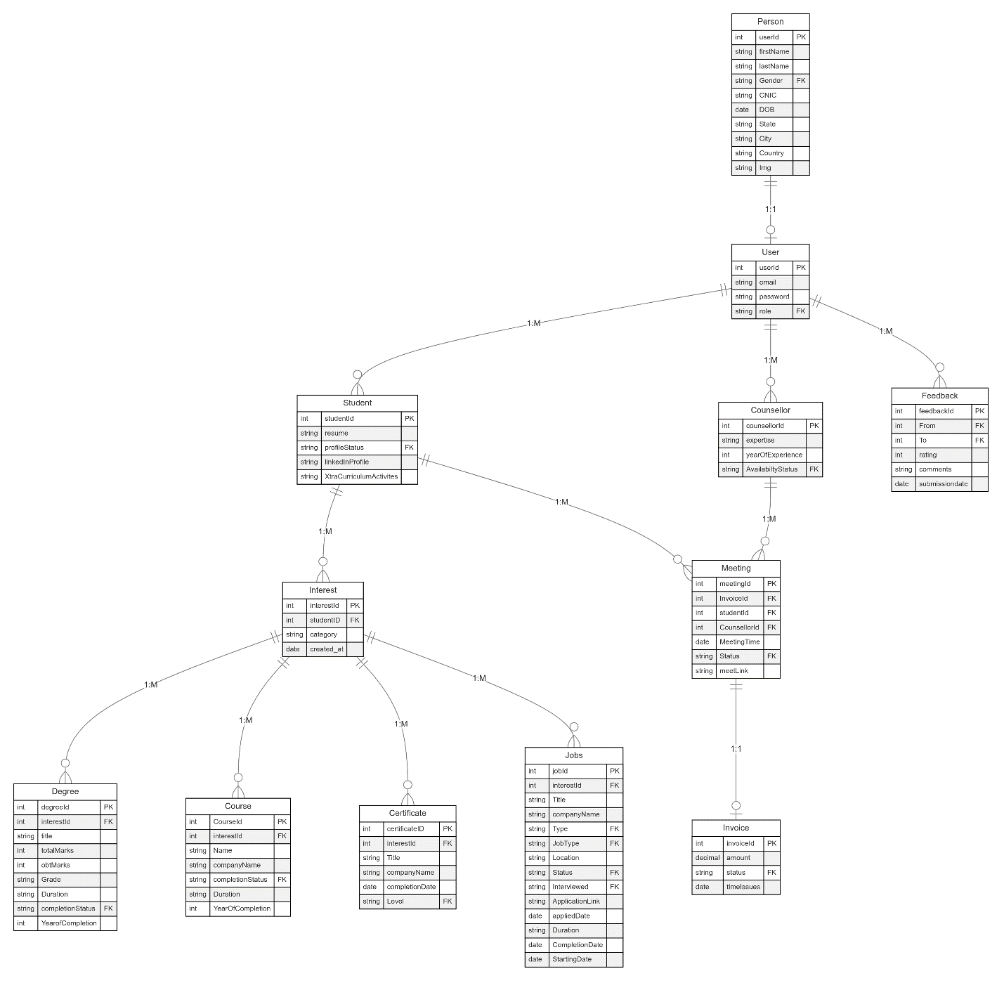

## Data Access Logic:

• **Queries to Fetch User Data for Login:**

* Fetch user information from the Users table based on the email and password provided during login.
* Identify the user’s role (student, counselor, or admin) and retrieve their detailed personal information from the Person table.

• **API Fetching for Job Listings and Recommendations:**

* Use external APIs such as LinkedIn Jobs API to fetch job listings and update the Jobs table with relevant job details for the students, including Title, CompanyName, Job Type, etc.

• **CRUD Operations:**

* **Student Records:**
  + Insert, update, or delete student data from the Students table.
  + Manage student's resume, LinkedIn profile, and extracurricular activities.
* **Counselor Records:**
  + Insert, update, or delete counselor data in the Counselor table.
  + Manage counselor expertise, experience, and availability status.
* **Meetings:**
  + Schedule, update, and cancel meetings between students and counselors using the Meeting table.
  + Update meeting statuses and generate or retrieve the meeting link (e.g., Zoom or Google Meet).
* **Invoices:**
  + Create and update invoices for meetings in the Invoice table.
  + Manage payment status and timestamps related to each session.

• **Interest and Degree Management:**

* Insert records for student interests in the Interest table.
* Manage academic degree details, such as marks, grade, and completion status, in the Degree table.

• **Course and Certification Management:**

* Store and retrieve information about courses a student has completed using the Course table.
* Manage certification records in the Certificate table, including the completion date and level of the certification.

• **Job Applications and Updates:**

* Insert and update job application status in the Jobs table, including job title, company, application link, interview status, and job duration.
* Fetch job details from external APIs and populate the Jobs table with new job opportunities.

• **Feedback System:**

* Insert feedback into the Feedback table after meetings or interactions, allowing students and counselors to rate and comment on their experiences.

• **Report Generation:**

* Generate comprehensive reports on students’ academic history, certifications, job applications, and meeting schedules by querying data from relevant tables (Degree, Course, Jobs, and Meeting).

# Layered Communication Flow

* **Front-end (React + JavaScript + HTML)** sends a request (e.g., user login or fetching job listings) to the **Node.js server** (via Axios or Fetch API).
* **Node.js (Business Logic Layer)** verifies the user’s credentials and checks their role (e.g., student, counselor, or admin) by querying the **MySQL (Data Layer)** for the relevant user data.
* If the user authentication is successful, **Node.js** fetches additional data (such as personalized career recommendations, job listings, or student dashboard information) from MySQL or external APIs (like LinkedIn for job listings).
* **Node.js** sends the appropriate data back to the **Front-end (React)**, where it's rendered as per the user role (e.g., student dashboard, counselor appointments, or admin controls).
* For operations like booking counselor meetings or updating student profiles:
  + **React (JavaScript)** sends an API request (e.g., scheduling a meeting or submitting profile changes) to **Node.js**.
  + **Node.js** processes the request, performs data validation and business logic, then updates the necessary records in **MySQL**.
  + **Node.js** responds with a success or failure message, which is displayed on the **Front-end**.
* For external operations such as fetching job listings:
  + **React (JavaScript)** sends a request to **Node.js**.
  + **Node.js** uses Axios or Fetch to get job data from external APIs (e.g., LinkedIn or other job platforms).
  + The response is stored in the **MySQL** database and sent back to the **Front-end** for display in the student dashboard.

# Example Breakdown for Career Path Navigator Features

## ****User Login (Authentication)****

* **Presentation Layer:**
  + Login form built with **React** for dynamic rendering and **Bootstrap** for responsive design.
  + Form validation with React hooks or JavaScript (client-side validation).
* **Business Logic Layer:**
  + Backend in **Node.js** (Express) handles login requests, validates user credentials, checks roles (Admin, Student, Counselor), and creates a session using **JWT** (if valid).
* **Data Access Layer:**
  + MySQL queries to retrieve user details (email, password, and role) from the **Users** table.

## ****Admin Dashboard****

### ****View & Manage Users (Admin)****

* **Presentation Layer:**
  + Built with **React** and **Bootstrap** for UI components like tables, pagination, and user management options (edit/delete buttons).
  + React for dynamic data binding and filtering/search functionalities.
* **Business Logic Layer:**
  + Node.js fetches user data (students and counselors), processes update/delete requests, and communicates with the MySQL database.
* **Data Access Layer:**
  + MySQL queries retrieve user data from the **Users** and **Person** tables.
  + View queries for managing users.

### ****View Feedback (Admin)****

* **Presentation Layer:**
  + **React** and **Bootstrap** for the feedback interface. Feedback dynamically loads based on user input or filters (rating, date).
* **Business Logic Layer:**
  + Node.js retrieves feedback data (ratings and comments) between students and counselors.
* **Data Access Layer:**
  + MySQL queries fetch feedback data from the **Feedback** table.

## ****Counselor Dashboard****

### ****Manage Availability (Counselor)****

* **Presentation Layer:**
  + Form built with **React** and **Bootstrap** for updating counselor availability, with form validation using React hooks.
* **Business Logic Layer:**
  + Node.js processes availability status updates and updates the counselor's availability.
* **Data Access Layer:**
  + MySQL updates availability status in the **Counselor** table.

### ****Schedule and Conduct Meetings (Counselor)****

* **Presentation Layer:**
  + **React** displays scheduled meetings. Links to join meetings (e.g., via Zoom) with real-time updates on the meeting status.
  + Real-time meeting status changes handled by React and WebSocket’s (or polling).
* **Business Logic Layer:**
  + Node.js fetches the counselor's scheduled meetings, generates meeting links, and updates the meeting status (pending, completed).
* **Data Access Layer:**
  + MySQL retrieves meeting data from the **Meeting** table and updates meeting status.

### ****View Feedback (Counselor)****

* **Presentation Layer:**
  + **React** interface for counselors to view feedback left by students after a session.
* **Business Logic Layer:**
  + Node.js fetches feedback related to the counselor.
* **Data Access Layer:**
  + MySQL queries retrieve feedback data from the **Feedback** table for the counselor.

## ****Student Dashboard****

### ****Profile Management (Student)****

* **Presentation Layer:**
  + **React** form for students to update personal details (resume, LinkedIn, extracurricular activities), styled using **Bootstrap**.
  + React handles file uploads and form validation.
* **Business Logic Layer:**
  + Node.js processes updates to the student's profile (e.g., resume, LinkedIn profile).
* **Data Access Layer:**
  + MySQL updates the **Students** table with the student’s profile data (resume, profile status, LinkedIn).

### ****View all Recommendation & Courses****

* **Presentation Layer:**
  + **React** interface for viewing all career recommendations and courses.
  + **Bootstrap** ensures responsive design for listings.
* **Business Logic Layer:**
  + Node.js fetches recommendations from external APIs (e.g., LinkedIn API) and processes job applications (stores data, updates application status).
* **Data Access Layer:**
  + MySQL stores job listings fetched from APIs in the **Jobs** table.
  + Application data and status updates are stored in MySQL.

### ****View and Apply for Jobs (Student)****

* **Presentation Layer:**
  + **React** interface for viewing job opportunities with filtering options (date, company, etc.). Data fetched from real-time APIs.
  + **Bootstrap** ensures responsive design for job listings.
* **Business Logic Layer:**
  + Node.js fetches job listings from external APIs (e.g., LinkedIn API) and processes job applications (stores data, updates application status).
* **Data Access Layer:**
  + MySQL stores job listings fetched from APIs in the **Jobs** table.
  + Application data and status updates are stored in MySQL.

### ****Schedule Meetings with Counselors (Student)****

* **Presentation Layer:**
  + **React** form for students to schedule meetings with counselors. Availability is checked in real-time.
  + JavaScript dynamically validates and displays available time slots.
* **Business Logic Layer:**
  + Node.js handles meeting requests, checks counselor availability, and schedules the meeting.
* **Data Access Layer:**
  + MySQL inserts meeting data into the **Meeting** table (studentId, counselorId, meeting time).

### ****Provide Feedback (Student)****

* **Presentation Layer:**
  + **React** form for students to submit feedback after counseling sessions.
  + **Bootstrap** styled feedback form, with dynamic rating system using React state management.
* **Business Logic Layer:**
  + Node.js processes feedback submissions, stores the data, and triggers any notifications.
* **Data Access Layer:**
  + MySQL stores feedback in the **Feedback** table (rating, comments, submission date).

# Tools and Frameworks

* **Backend Framework:** Use **Node.js** with **Express.js** for managing routing, middleware, and business logic efficiently.
* **Frontend Framework:** Use **React.js** along with **Bootstrap** and **Tailwind CSS** for building interactive, responsive user interfaces and ensuring a smooth user experience.
* **Database:** Use **MySQL** for database management, including **MySQL Workbench** for database design and management.
* **API Integration:** Use **Axios** or **Fetch API** in React to interact with external APIs such as **LinkedIn** for fetching job listings and other external data sources.
* **Authentication:** Implement **JSON Web Tokens (JWT)** for secure user authentication and session management across roles like Students, Counselors, and Admins.

This layered architecture allows for clear separation of concerns, with each layer responsible for a distinct part of the school system. It ensures that changes in one layer (e.g., UI or database) don’t significantly impact others